ADO 13401

Steps to replicate:

1. Create a quote with the Program
2. Complete the quote and progress to the Letter tab
3. Go back to the Common tab and remove the Program selected
4. Bind premium and then 'Request to Bind.'
5. Open the Request to Bind email and check the 'Program' details

Actual result:

Removed Program still indicated in the 'Request to Bind email

Expected result:

The 'program' should be blank

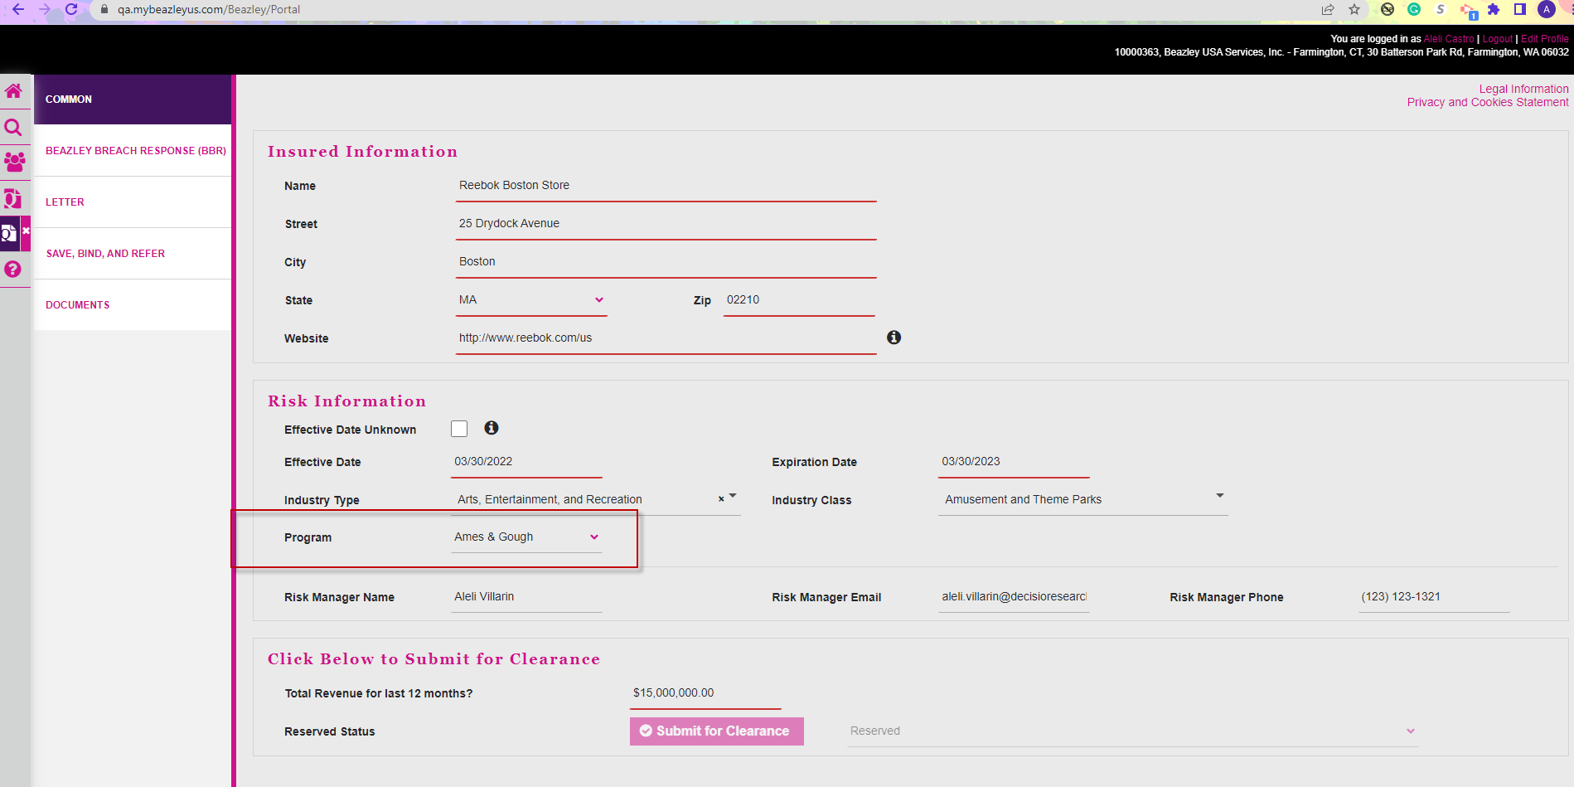

Before Requesting to Bind the quote



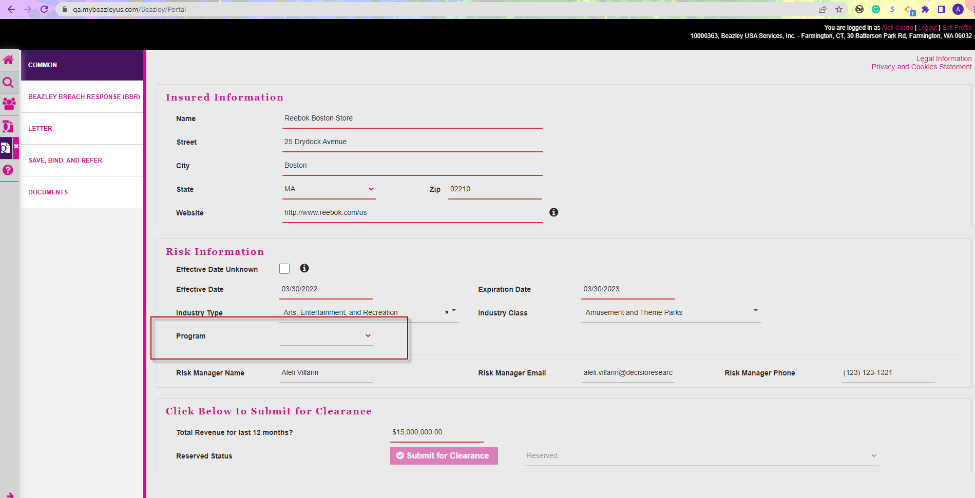

Request to Bind email still display the removed Program

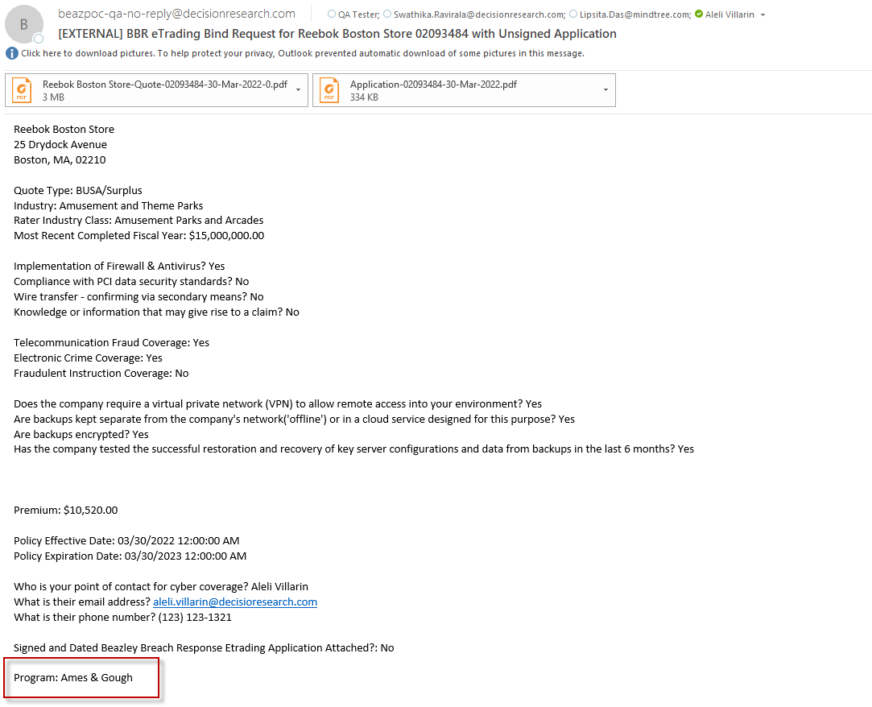

**Re-testing:**

Created a new Quote, selecting Industry Type, Industry Class and a Program.

Then I selected back the Program to empty.



